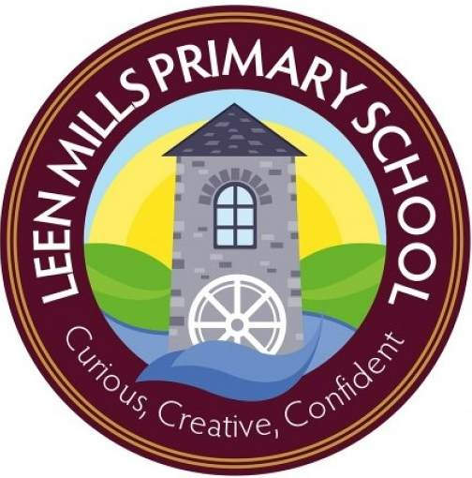

Ofsted

Dear Families of Leen Mills,
As you know we had a visit from Ofsted on Tuesday 6th June and Wednesday 7th June and our report is now available on the school website.
We are incredibly proud to say that Leen Mills has been judged to be a GOOD school.
As I have said many times before, Ofsted see a snapshot of what life is like in school, but the staff and I were determined for the inspectors to see just what life in school is like day in and day out for our pupils. This is just what we did. The report sums up our school beautifully.
I know there has been a lot in the press about Ofsted and the way schools are inspected at the moment, but we all found the process to be fair and transparent. The team of inspectors worked with staff and listened to us. Don’t get me wrong we had to answer some deep, challenging questions but we were able to answer quickly and effectively.
In my letter after the inspection, I told you that the children were the stars of the show and they really were! They showed just how wonderful they are. The whole inspection team commented on their manners, their attitude and how positively they spoke about life at Leen Mills. I think the team must have spoken with at least 1/3rd of all the pupils in school. All of them spoke about how proud they are of this school and how they feel part of the Leen Mills family – this just makes me so happy.
Leen Mills was first judged to be RI 6 years ago and I would be lying if I did not say that it had an impact on the staff at school. But from a devastating judgment our resistance only deepened. Together as a team we were determined to turn things around. We listened to advice, we worked together to improve things, it was not always easy, but we had a common goal…making sure everyone knows just how good we are. We would not have got our GOOD judgement without the staffs’ commitment and determination. I am immensely proud of each and every one of them and want to say a BIG BIG thank them all for their hard work, I could not ask for a better team – as you will read in the report we are Team Leen Mills.
I hope you enjoy reading the report as much as we did.

Thank you for your continued support,
Mrs Goldson

