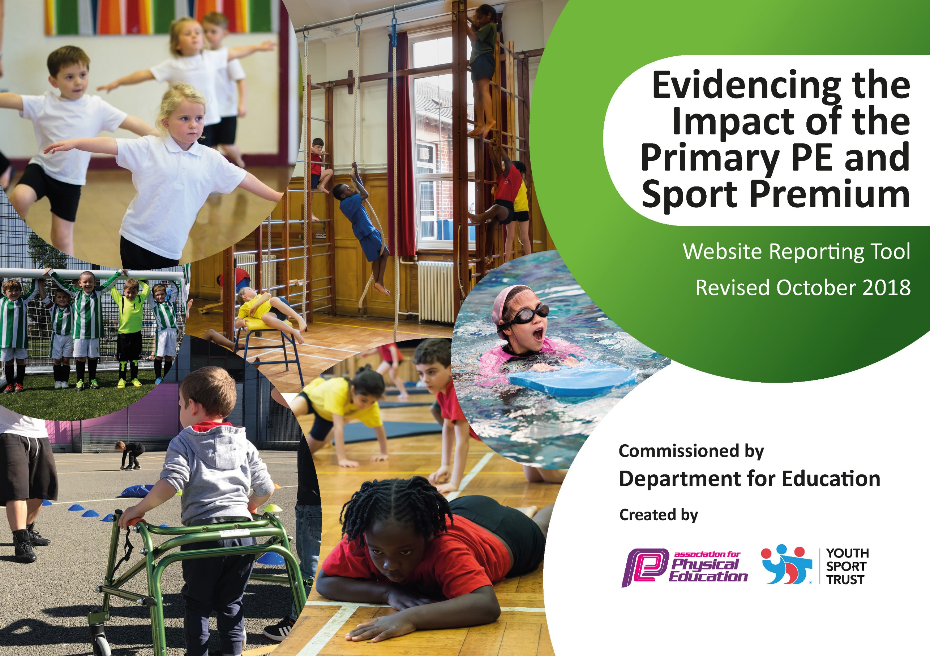
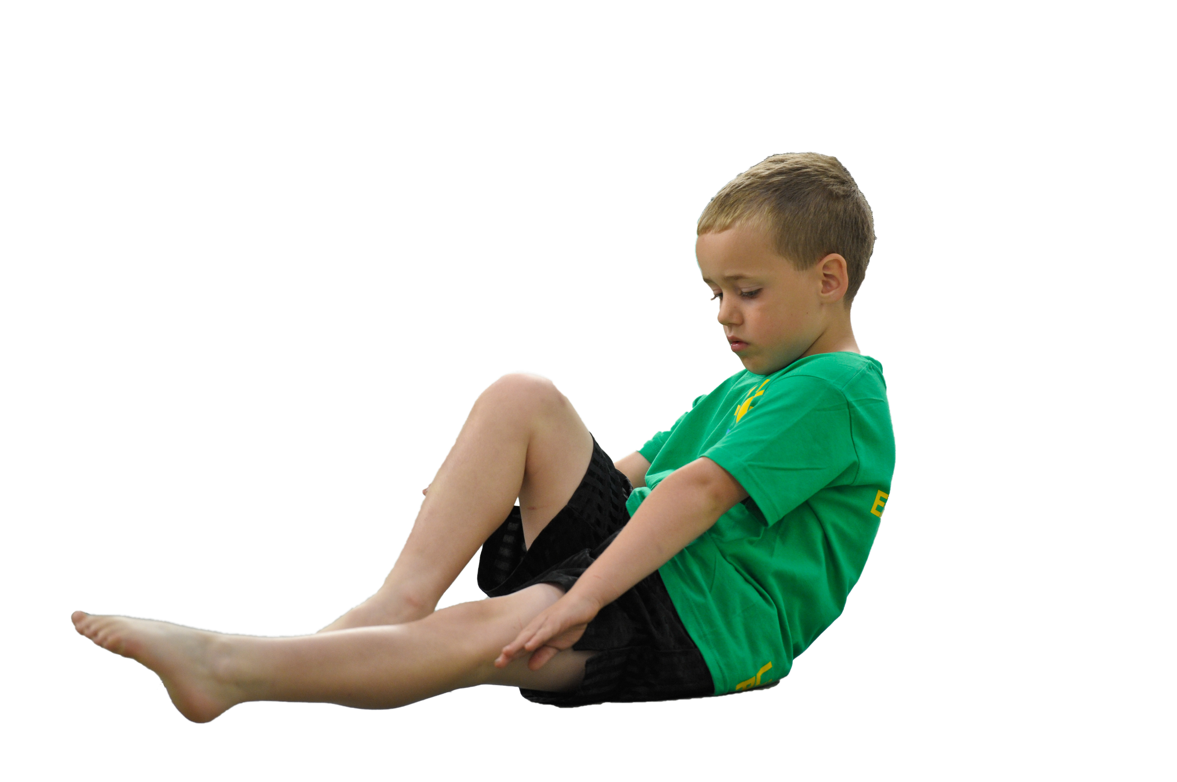
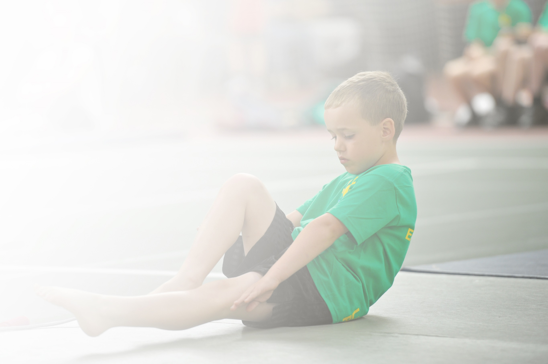
Schools must use the funding to make additional and sustainable improvements to the quality of Physical Education, Sport and Physical Activity (PESPA) they offer. This means that you should use the Primary PE and Sport Premium to:

- Develop or add to the PESPA activities that your school already offer
- Build capacity and capability within the school to ensure that improvements made now will benefit pupils joining the school in future years

Please visit gov.uk for the revised DfE guidance including the 5 key indicators across which schools should demonstrate an improvement. This document will help you to review your provision and to report
your spend. DfE encourages schools to use this template as an effective way of meeting the reporting requirements of the Primary PE and Sport Premium.

We recommend you start by reflecting on the impact of current provision and reviewing the previous
spend. Under the Ofsted Schools Inspection Framework, inspectors will assess how effectively leaders use the Primary PE and Sport Premium and measure its impact on outcomes for pupils, and how effectively governors hold them to account for this.

Schools are required to publish details of how they spend this funding as well as on the impact it has on pupils’ PE and sport participation and attainment by the end of the summer term or by 31 July 2019 at the
latest.
We recommend regularly updating the table and publishing it
on your website throughout the year, as evidence of your
ongoing review into how you are using the money to
secure maximum, sustainable impact. To see an
example of how to complete the table please
click HERE.

Support for review and reflection - considering the 5 key indicators from DfE, what development needs are a priority for your setting and your students now and why? Use the space below to reflect on previous spend, identify current need and priorities for the future.

Key achievements to date: | Areas for further improvement and baseline evidence of need:
- Participated in many School Games competitions  - Achieved School Games Marks- bronze, silver and gold  - Gold for 2018-2019-2020-2021  - Taken part in football league matches and successfully hosted  - Children through to District Finals in variety of competitions  - Active home-learning activities made available  - Active home-learning competitions carried out  - Increase from the previous year of chn meeting swimming requirements | - As a school, we aim to achieve the Gold Mark Award again for the academic year 2021-22  - To ensure active 30 is pushed within school  - To ensure FS are being active within their exploring and learning time  - To decrease the percentage of inactive children from baseline (Premier Education)  - To implement active learning in other areas of the curriculum

Meeting national curriculum requirements for swimming and water safety | Please complete all of the below:
What percentage of your current Year 6 cohort swim competently, confidently and proficiently over a distance of at least 25 metres?  Learn to Swim Stage 6  N.B. Even though your children may swim in another year please report on their attainment on leaving  primary school. | 95%
What percentage of your current Year 6 cohort use a range of strokes effectively [for example, front crawl, backstroke and breaststroke]?  Learn to Swim Stage 5 | 75%
What percentage of your current Year 6 cohort perform safe self-rescue in different water-based situations? Learn to Swim Stage 6 | 50%
Schools can choose to use the Primary PE and Sport Premium to provide additional provision for swimming but this must be for activity over and above the national curriculum requirements. Have you used it in this way? | Yes, additional swimming lessons for year 6 who have not achieved their 25m.

Action Plan and Budget Tracking
Capture your intended annual spend against the 5 key indicators. Clarify the success criteria and evidence of impact that you intend to measure to evaluate for students today and for the future.

Academic Year: 2021-2022 | Total fund allocated: | Date Updated:
Key indicator 1: The engagement of all pupils in regular physical activity – Chief Medical Officer guidelines recommend that primary school children undertake at least 30 minutes of physical activity a day in school |  |  |  | Percentage of total allocation:
 |  |  |  | £10,051.56 49%
School focus with clarity on intended impact on pupils: | Actions to achieve: | Funding allocated: | Evidence and impact: | Sustainability and suggested next steps:
Premier Education:  - New and exciting lessons to be delivered to all year groups  - After School Clubs to encourage an active lifestyle  - Lunch time football training to help support PE teacher and help chn practise different skills ready for match days  - PE specialist encourages physical activity during breakfast club  Classes to be encouraged to take part in the Leen Mills Mile (Daily Mile).  Foundation Stage chn to develop confidence, balance and coordination through balance bikes. Equipment to be replaced and improved throughout the year.  - 40-60 months- Physical Development: to negotiate space effectively.  - To travel with confidence…through balancing.  - ELG- Physical Development: to show good control and coordination…  Foundation Stage to have a range of sporting equipment to help develop moving, catching, control, coordination, confidence. This will also help the chn become aware of leading a healthy and physical lifestyle.  Each class to have a stepper to track the number of steps taken during the school day and compete with 3 other classes.  Mintridge Foundation workshop and assembly delivered. Paralympian shared her journey encouraging chn to follow their dreams and aspirations and always say yes to a new challenge.  Mintridge to be booked for KS1 to experience workshops.  Playground markings on KS1 and KS2 to encourage active playtimes.  Music production for KS1, which enables the chn to experience, dance within the production.  KS1 children to experience exploring on an adventure playground.  Chn to be taken to competitions as a team. | External coach to deliver new, fun and exciting activities additional to PE lessons in school. Specialist coach from Premier delivers lunch and after school clubs to promote and deliver active and healthy lifestyles.  Classes to take part in the Leen Mills Mile- encouraged to improve their own distance (or time) within 15 minutes.  FS chn to take part in balance bikes with fresh and new equipment.  Ramps to challenge chn to try exciting/daunting new activities. It will extend the chn who are more than capable on the balance bikes.  Outdoor equipment to be purchased to ensure FS chn are able to use a range of equipment confidently and contribute towards their active lifestyle.  Chn to be engaged in active steps during the school day. They are enthusiastic about wanting to gain the most steps.  All classes took part in an assembly. KS2 had workshops and question and answer time.  All chn will have experienced class workshops with an Olympian/Paralympian.  Playground markings painted on the playground and teachers/middays encourage the use of them during playtimes/lunchtimes.  All KS1 chn take part in a school production, which includes dance skills.  KS1 children to be taken to Southwell Minster playground after their RE Pilgrimage Day.  CJ to take the chn to sporting events as a team. | £2,9892  FREE  £142.50 bikes  £59.96 ramps  £412 County Supplies and CosyDirect  £95.98  £975  £960  £4185  £54.12  £10  £175- Vallances Coaches | All chn in the school have accessed a variety of sports offered from Premier. Chn have had the opportunity to access extra-curricular PE.  All chn are taking part in the Leen Mills Mile weekly and have improved fitness levels.  All FS chn can use a balance bike effectively.  Chn who are more competent to use the ramps.  Chn are using the equipment and contributing towards the active 60 minutes in their day (30 within school).  All classes in school are being engaged in active stepping and healthy competition throughout each school day.  Chn understand importance of trying new things and saying yes to challenges.  All chn met an Olympian/Paralympian and can follow their own dreams.  Chn are using the playground to be active in a variety of ways that will help towards their 60 minutes of physical activity each day.  All chn experience dance within their production.  KS1 have accessed an adventure playground.  Chn to take part in the sporting event for school. Transport isn’t a factor. | Carry out a pupil voice to gather staff and pupil views on Premier Education.  Continue to provide extra PE for all chn including a number of specific groups.  Leen Mills Mile is embedded within the school week.  FS chn are able to use the balance bikes properly. Staff are able to teach future chn effectively after having been in on the training.  Bikes can be used in future years and will need to be looked after and replaced when necessary. Ramps also available for future use.  Classes to look after their steppers and they will be able to be used in future years. Building on each year, chn will be enthusiastic about wanting to carry on and beat personal bests from the time before.  Chn are able to challenge themselves physically and mentally.  More ideas on the playground- from the pupil voice?  If staff/parents/carers are unable to help with transporting parents, coaches can be booked.

Key indicator 2: The profile of PESPA (Physical Education, Sport and Physical Activity) being raised across the school as a tool for whole school improvement |  |  |  | Percentage of total allocation:
 |  |  |  | £8,915.45 44%
School focus with clarity on intended impact on pupils: | Actions to achieve: | Funding allocated: | Evidence and impact: | Sustainability and suggested next steps:
Friday achievement assembly always begins with the weeks sporting news (competitions, match results, outside sporting achievements etc.).  Sporting achievements celebrated on Class Dojo as well as the Leen Mills PE Twitter page.  PE lessons shared on Class Dojo.  Encouragement for School Games Days (Sports Days)- each child to receive praise and a sticker (1st, 2nd, 3rd and Well Done).  New resources ordered to ensure the profile of PE is kept to a high standard.  Sportsafe UK Ltd to check and ensure all resources used are of high-quality and meet the highest of safety standards.  CJ to host football tournaments at Leen Mills Primary School.  Sports Ambassador Training for year 6 pupils.  Sports Ambassador clothing to highlight their importance.  Sensory equipment to help aid with fine motor skills.  Food tasting day to encourage healthy eating. (WB 13/12/21).  Friday achievement assembly certificates.  Equipment revamp to keep the PE profile fresh and at the forefront of the curriculum. This includes Bell Balls (£128 for 6) for equality when playing Invictus Games. | Ensures the importance of PE across the school and encourages all chn to aspire to be involved in achievement assemblies.  Parents are involved with sharing sporting achievements.  Parents have an insight into lessons and can comment on achievements.  All chn encouraged for taking part and trying their best.  Top quality resources ensure chn look after them and are receiving high quality equipment to use.  All PE equipment is fully safe for the chn to use.  To ensure the family of schools are included in the tournament.  All sports ambassadors to take part in training and are confident to run level 1 competitions in school.  Sports ambassadors wear bibs and hats to be noticed to the other chn on the playground.  Chn who take part in Tree House sessions are able to use the equipment to help aid fine motor skills.  All chn to carry out a food tasting session trying varied foods and discussion of which food group it comes from.  CJ to choose one child per week to receive the head teacher’s award.  PE equipment ordered to be used across the school. | Free  Free  Free  £20 Sticker price  Sports Directory: £1792.69  Climbing frame: £4620 inc VAT  £162  (repairs)  Free  Free  £79.19  £139.96  £200  KG certificates  Free  £855.35 Sports Directory  Davies Sports £1,046.26 | Chn to be congratulated on their achievements with the whole school.  Chn’s confidence to be boosted and shared with the whole school, including parents.  Profile of PE raised to parents.  All chn feel valued and happy and have been recognised for their successes.  Chn treat the equipment with respect and can recognise the value of having new, high-quality resources.  All equipment is safe to use and is been checked by a company. Equipment paid for and replaced if necessary.  Chn have increased participation in competitive sports and LMPS learn how to host successfully whilst showing great sportsmanship.  All sports ambassadors run level 1 competitions throughout the year offering a range of activities for different year groups.  SA’s wear clothing with pride and are able to be noticed by the other chn.  Chn who work with the nurture specialists are able to be physical in their sessions focusing on fine motor.  All chn understand the importance of a healthy and balanced diet and understand how to use the food pyramid to help.  Ensures PE is acknowledge when it comes to praise and achievements. All chn will work hard to be chosen for the certificates.  Equipment being used by PE specialist and class teachers. Chn to understand how sports can be played with a disability such as blindness. | School Games funding to be continued to allow the chn to take part in organised events.  Teachers to continue to share achievements and PE lessons on Class Dojo and social media to celebrate success.  PE equipment to be checked termly and replaced, revamped or restocked when necessary.  Equipment checked regularly by Sportsafe UK Ltd. Funding to be adapted as and when necessary to replace.  CJ to continue to plan, organise and host football tournaments to ensure the profile of PE is high at all times.  Year 6 pupils to train the year 5 upcoming sports ambassadors.  Clothing to be used in future years.  Equipment can be used with a variety of chn with additional needs to help support physical activity.  Chn follow a healthy diet.  Certificates to continue to be handed out across both key stages.  Equipment can be used in future years.

Key indicator 3: Increased confidence, knowledge and skills of all staff in teaching PE and sport |  |  |  | Percentage of total allocation:
 |  |  |  | £110 1%
School focus with clarity on intended  impact on pupils: | Actions to achieve: | Funding  allocated: | Evidence and impact: | Sustainability and suggested  next steps:
Course: Active Notts PE Conference for JE and CJ  - Keynote speakers  - Deep Dives in PE  - Networking over lunch  - Providing an overview of the PE Coordinator role and the impact and support provided by the School Games programme  - Ashfield SGO session  - Plus Involving Families for CJ  Premier Education working in different classes each half term.  CJ to have a laptop to use in PPA PE lessons to ensure SoL’s, prior learning, key vocabulary and any video clip examples can be shared. | JE and CJ to use ideas from the course and carry out at school.  Chn experience a different coach and different sports.  CJ to have a class laptop. | JE and CJ release time (full day)  £110 for the course for 2 (early bird offer)  Premier cost above  Price TBC! | Ideas are being implemented in school to develop practice. See ‘Give Me 5’ hand for course feedback.  Chn experience a variety of sports.  CJ is able to share statement of learning with the chn, key vocabulary, video clip examples and prior learning. | Active learning to take place in some lessons.  Chn broaden their horizon on which sports they can take part in.  Laptop is sustainable each year in the future to be used in PE lessons.

Key indicator 4: Broader experience of a range of sports and activities offered to all pupils |  |  |  | Percentage of total allocation:
 |  |  |  | Prices in other K.I’s
School focus with clarity on intended  impact on pupils: | Actions to achieve: | Funding  allocated: | Evidence and impact: | Sustainability and suggested  next steps:
Premier Education booked in for the whole of the academic school year.  Some chn are chosen to take part in after-school events to represent the school. (see K.I.3 above). | All chn taken part from FS to Year 6. Chn chose their own activities. | See above Premier Education price. | All chn have experienced physical education, outside of what is delivered during the school day by CJ  ASC have been offered to a variety of groups including the vulnerable chn.  More chn are being active outside of the school day. | Discuss with pupils through pupil voice about the activities taken place and also carry out another staff feedback form.  Chn are aware of the importance and enjoyment of an active afterschool club.

Key indicator 5: Increased participation in competitive sport |  |  |  | Percentage of total allocation:
 |  |  |  | £1,300 6%
School focus with clarity on intended  impact on pupils: | Actions to achieve: | Funding  allocated: | Evidence and impact: | Sustainability and suggested  next steps:
Ashfield District School Sports Network- cost is delivered towards a School Games Organiser and this enables more competitions to be organised targeting a wider range of chn.  CJ to take chn to the organised after-school competitions.  Football Affiliation Fee to ensure the football team is able to take part in competitive matches in the league.  Sports Ambassadors (Years 5 and 6) arrange weekly competitions for different year groups. | Chn to be taken to the School Games competitions both inside and outside of the school day.  Chn to be taken by CJ to after-school events.  School football team to take part in league matches.  Trained chn are able to plan, organise, deliver and record competitions using School Games formats. | £750  £500  £50  Free- part of School Games | A high percentage of chn are able to take part in competitive and non-competitive competitions with schools from the district.  A range of chn able to access after- school events.  The boys to have experienced high-quality participation in competitive matches through a league.  Chn are confident when planning and delivering competitions. They are able to record results on to School Games website using Sports Ambassador iPad. | Continue access the network to ensure increased participation in competitive sports against other schools.  CJ to continue to choose a range of chn, allowing them to experience competition.  Continue to pay the affiliation fee to be included in the competitive league fixtures.  CJ to oversee competitions being planned during Tuesday break-times. JE to oversee recording of competitions on the School Games website during Creative Curriculum time.

Total spent: £20,377.01

